**Seyed Hossein Mohammadi (96222096)**

**Project 2 – Population Modeling**

1. Fully connected 800 excitatory and 200 inhibitory AELIF with the following config with J=6.5:



Test 1:

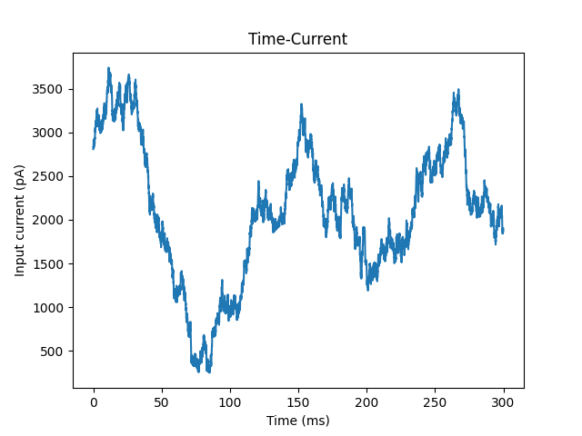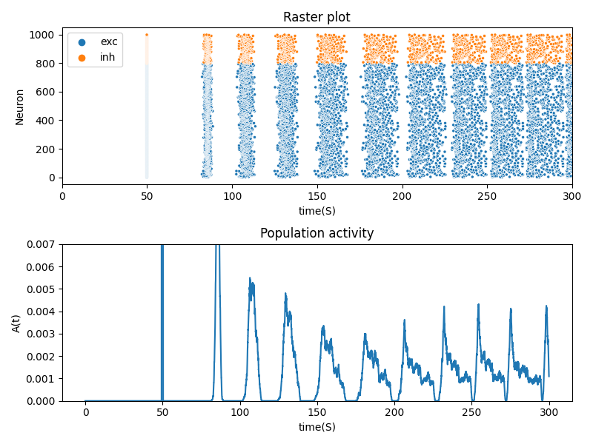

Test 2:

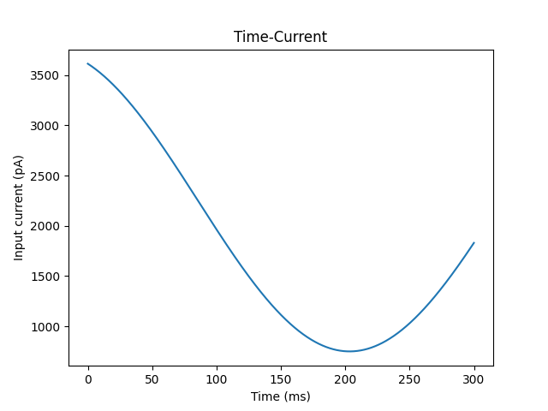

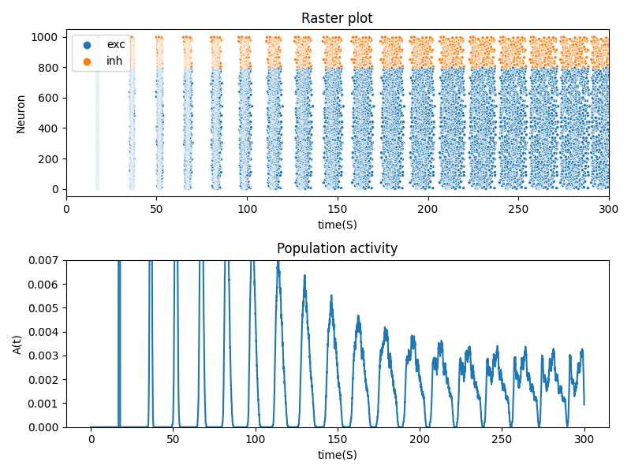

Test 3: similar to test 1 but 3 times the time.

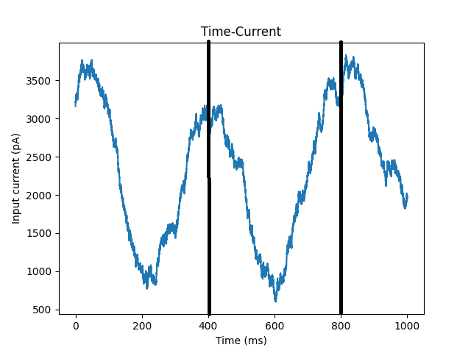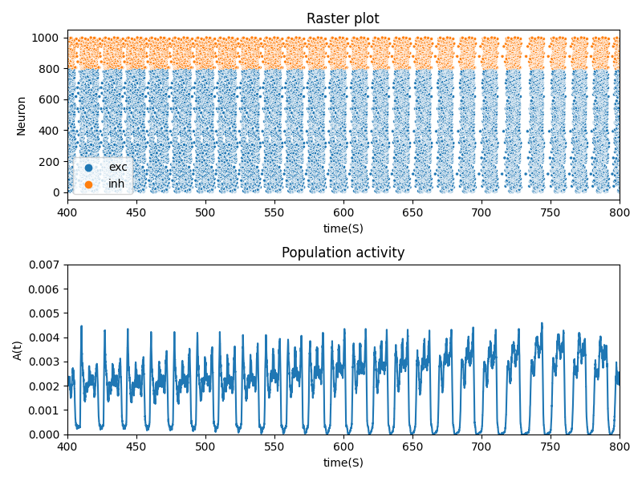

POP1: fully connected 800 excitatory and 200 inhibitory AELIF with the following config with J=6.5



POP2: fully connected 300 excitatory and 100 inhibitory LIF with the following config with J=5.5:



Pop1 is fully connected and directed to pop2 with J=10.

Test 1:





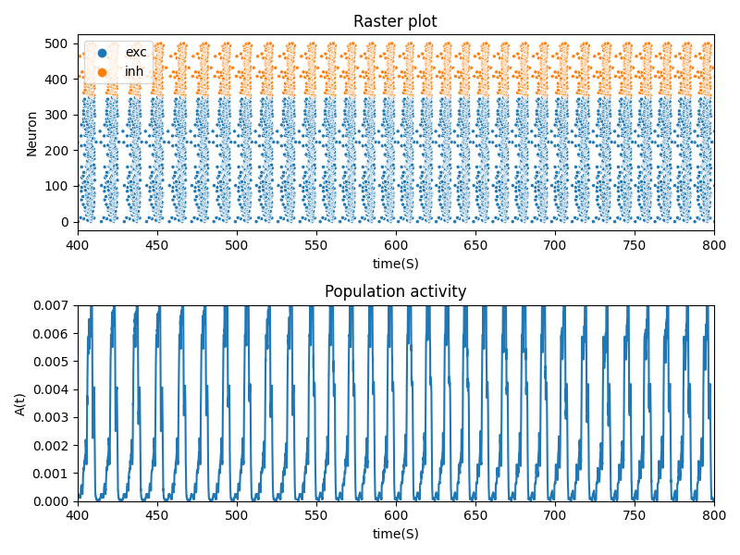

Test 2:

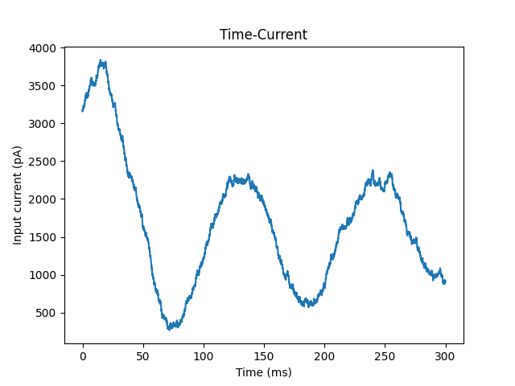

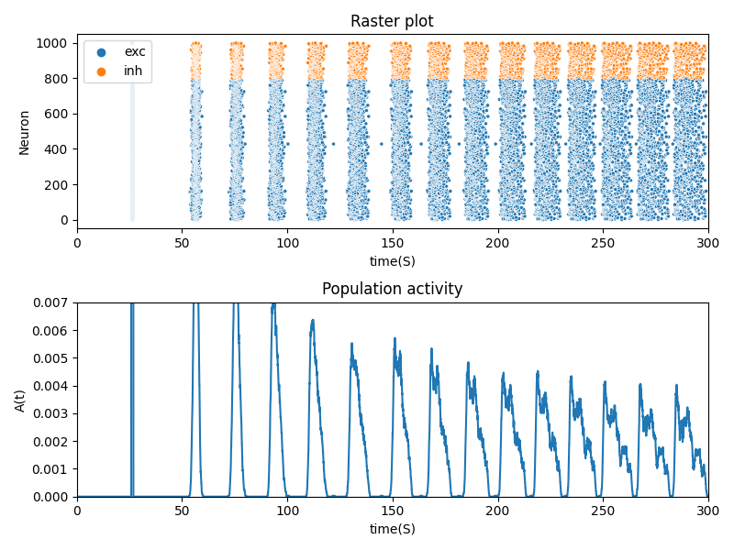

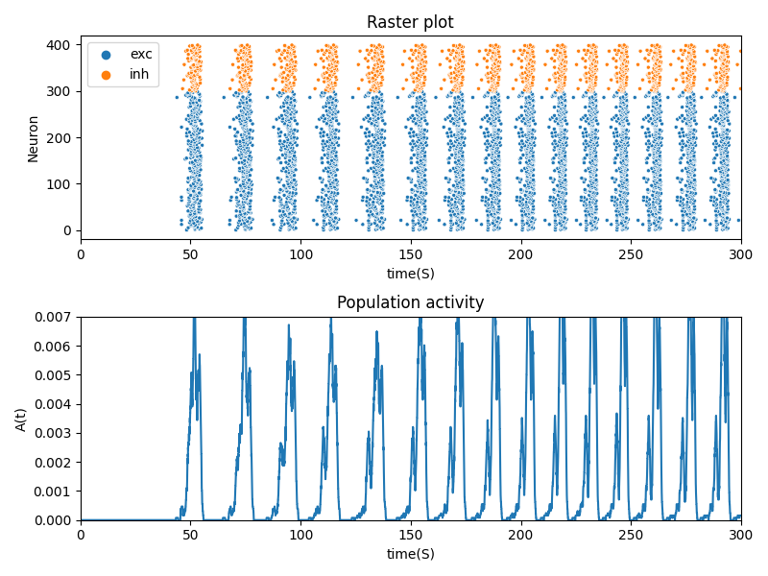

Test 3:

